 | STUFFING BOX PACKINGS
 | AVKOPACK 1101/101 | 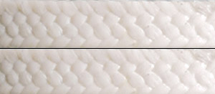

documentation
 | Composition | PTFE + lubricant

 | AVKOPACK 1101S/101S | 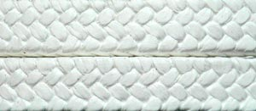
 | documentation
 | Composition | PTFE

 | AVKOPACK 1120/120 | 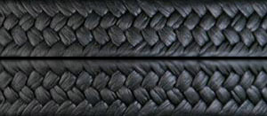
 | documentation
 | Composition | PTFE/graphite + lubricant

 | AVKOPACK 1120G | 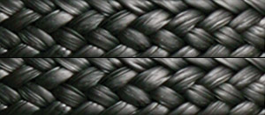
 | documentation
 | Composition | PTFE/graphite + lubricant

 | AVKOPACK 1201/201 | 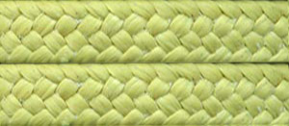
 | documentation
 | Composition | aramid, PTFE + lubricant

 | AVKOPACK 1201P/201P | 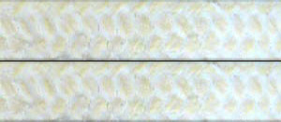
 | documentation
 | Composition | staple aramid, PTFE + lubricant

 | AVKOPACK 1201M | 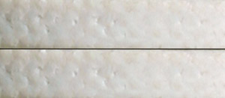
 | documentation
 | Composition | m-aramid, PTFE + lubricant

 | AVKOPACK 1202/202 | 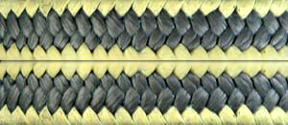
 | documentation
 | Composition | PTFE/graphite/ aramid + lubricant

 | AVKOPACK 1203/203 | 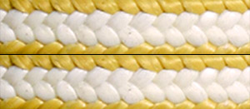
 | documentation
 | Composition | PTFE/aramid + lubricant

 | AVKOPACK 1301/301 | 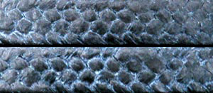
 | documentation
 | Composition | carbon fibres + lubricant

 | AVKOPACK 1302/302 | 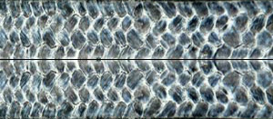
 | documentation
 | Composition | carbonised fibres + PTFE

 | AVKOPACK 1320*/320* | 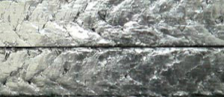
 | documentation
 | Series stuffing box packing braided from expanded graphite yarn. Depending on the type of the yarn are offered different kinds of packings according to the requirement to exploitation characteristics.
 | Carring fibre | Type packing
 | cotton | AVKOPACK ® 1320 C
 | glass | AVKOPACK ® 1320 G
 | aramid | AVKOPACK ® 1320 K
 | carbon | AVKOPACK ® 1320 B
 | cotton+inconel | AVKOPACK ® 1320 CI
 | glass+inconel | AVKOPACK ® 1320 GI
 | inconel | AVKOPACK ® 1320 I
 | polyamid | AVKOPACK ® 1320 P
 | cotton+steel | AVKOPACK ® 1320 CS
 | glass+steel | AVKOPACK ® 1320 GS
 | stainless steel | AVKOPACK ® 1320 S
 | outer cabling with inconnel | AVKOPACK ® 1320 X

 | AVKOPACK 1320X | 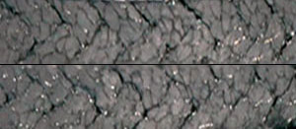
 | documentation
 |  | AVKOPACK 1320X is a diagonally braided packing, manufactured after a special technology in order to guarantee high exploitation parameters.

 | AVKOPACK 1331 | 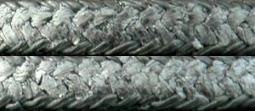
 | documentation
 | Composition | exp. graphite / carbon

 | AVKOPACK 1360 | 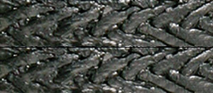
 | documentation
 | Composition | exp. graphite / ceramic

 | AVKOPACK 1400/400 | 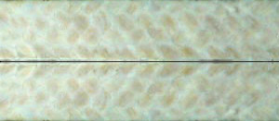
 | documentation
 | Composition | cotton, PTFE + lubricant

 | AVKOPACK 1401/401 | 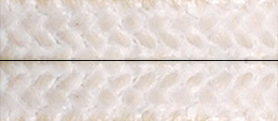
 | documentation
 | Composition | ramie, PTFE + lubricant

 | AVKOPACK 1402/402 | 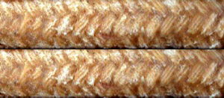
 | documentation
 | Composition | cotton + lubricant

 | AVKOPACK 1402G/402G | 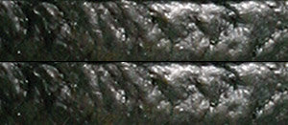
 | documentation
 | Composition | cotton, graphite + lubricant

 | AVKOPACK 1502/502 | 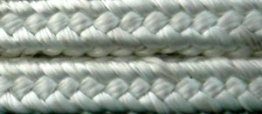
 | documentation
 | Composition | glass

 | AVKOPACK 1502H | 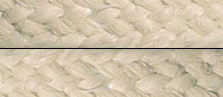
 | documentation
 | Composition | glass + special silicate system

 | AVKOPACK 1513 | 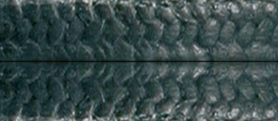
 | documentation
 | Composition | glass, PTFE, graphite

 | AVKOPACK 1520 | 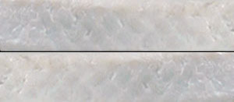
 | documentation
 | Composition | glass, PTFE

 | AVKOPACK 1530 | 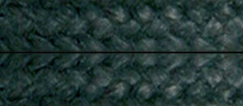
 | documentation
 | Composition | glass, graphite

 | AVKOPACK 1602/602 | 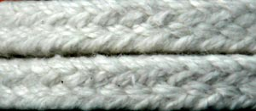
 | documentation
 | Composition | ceramic

 | AVKOPACK 1720/720 | 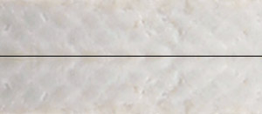
 | documentation
 | Composition | Acrylic, PTFE

 | AVKOPACK 1730 | 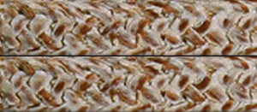
 | documentation
 | Composition | Novoloid, PTFE + lubricant

AVKOTOOL 11 - DEVICE FOR CUTTING OF PACKINGS
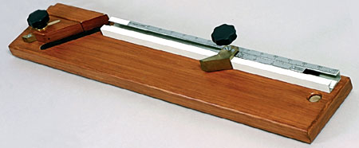
Used for cutting of stuffing box packing at length determined by the diameter of the shaft and the dimensions of the vertical section of the packing.
Gives a possibility of working at a maximum diameter of the shaft up to 140 mm. The maximum size of the packing is 25 x 25 mm. The usage of this instrument garantees the cutting of the packing at the length and reqiured angle needed for achieving a maximum jointing effect. A precisely cut packing decreases the appearance of relatively soft areas, the waste of material and time.

AVKOTOOL 12 - EXTRACTORS
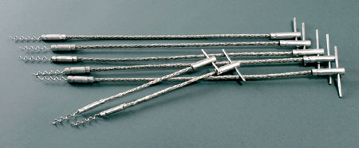
The extractors take apart the used stuffing box packings from the deep hardly reachable parts of the stuffing boxes. The presence of even minimal quantity of the old dry and compressed stuffing box packings may decrease to minimum the effect of its change with a new one, because this leads to increased wearing out of the shaft and unwanted leaking of the working fluid.

 | 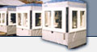 | PACKING PRODUCING MACHINES
Description of the machines
The high-qualified AVKO knitting machines are elaborated and produced as a result of many years’ works in the area of the industrial insulation materials. The direct supervision of their performance in the production process gives the opportunity for a permanent improvement of the producing machines, for the complete satisfaction of the highly set requirements of the contemporary insulation materials.
The diagonally AVKO knitting machines are used for the production of high-quality stuffing box packing, cords, ropes. The construction of the machines gives the opportunity for the product to be impregnated if necessary, at regulated temperature of the impregnator. The machines are easily knitting two-, three- and four-diagonal insulating products as well as from high-qualified yarns as aramide, PTFE, carbon fiber, glass fiber, ceramic. etc.
The supply with universal brackets allows the simultaneous usage of several types of yarns. Due to the glass-aluminum defense the machines with lowered level of noise allows a permanent control on the technological process. The high reliability of the machines allows their exploitation at three-shift rate.
Advantages
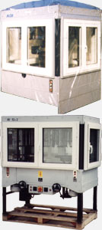 | - Minimum dust in the working area due to the presence of a plug-in inlet for the aspiration system;  - Unleveled easy electronic regulation of the speed of the machine, depending on the yarns used;  - Regulation of the yarn tension for obtaining various densities of the packing;  - Electronic regulation of the temperature of the impregnation bath and its visualization;  - Electronic counter of the length of the produces packing, in meters;  - Electronic counter of the wrking hours of the machines;  - Fast change of the calibrating element;  - Easy service;  - High productivity;

Technical characteristics
Parameter | Measure unit | Model of the machine
 |  | AV 8 | 2 x AV 12 | AV24
Head numbers | pcs. | 1 | 2 | 1
Bracket number | pcs. | 8 | 2 x 12 | 24
Dimensions range | mm | 3x3÷6x6 | 6x6÷12x12 | 8x8÷22x22
Diagonal numbers | pcs. | 2 | 3 | 4
Delivery voltage | V | 380 V - 50 Hz | 380 V - 50 Hz | 380 V - 50 Hz
Capacity of the el. motor | kW | 0,55 | 2 x 0,75 | 1,5
Revolutions of the el. motor | min⁻¹ | 750 | 750 | 1000
Dimension of the coils Ø x L | mm | 70 / 250 | 70 / 250 | 70 / 250
Outside dimensions L x B x H | mm | 1210 / 900 / 1720 | 1670 / 1210 / 1720 | 1560 / 1550 / 2600
Weight | kg | 700 | 1200 | 1500

 | 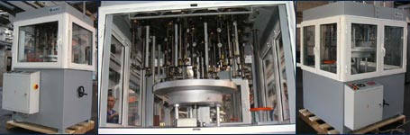

PACKING INSTALLATION PROCEDURES
In order to be increased the term of exploitation of the machines and the equipment and also in order to be secured their reliability it is necessary for you to follow the Instruction for installation of packings. It is recommended from ESA (European Sealing Association). We are members of ESA.
Instruction is available in PDF format.
download

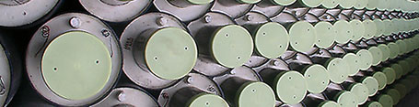

Pre-insulated Piping Systems (PIPS)
The Pre-insulated Piping Systems (PIPS) supplied by AVKO jsc have the following major advantages:
- Excellent heat insulating characteristics, resulting in minimal heat losses.
- Exceptional durability - the PUR insulation layer is characterized with exploitation term up to 30 years at working temperature of the heat carrier of 120 °C. In case the temperature of the working fluid is lower the exploitation term is longer.
- Easy, fast and economically advisable installing process, compared to the traditional building of district heat pipelines - for each particular project it is possible to be designed specific fittings and joints.
- It is possible to be built in electronic system to indicate and locate any leeks along the pipeline as well as any oozing of moisture in the insulation layer. Our production program include both most common monitoring systems - Brandes and Nordic wire.

Materials used for the production of pre-insulates piping systems
All of the materials as well as their quality conform to BSS EN 253:2003 and BSS EN 448:2003.
- Carrier pipe
  - Steel welded pipes that conforming to EN 10217, DIN 1626
  - Steel seamless pipes that conform to EN 10216, DIN 1629
- Heat insulating layer of PUR foam
  - This foam is a two-component system (mixture of polyol and isocianate) with foaming agent pentane, CO₂ or another (we do not use freon systems). The ready mixture has homogeneous cellular structure with average heat conductivity factor less than 0,034 w/mK.
- Jacket HDPE pipe (high-density polyethylene)

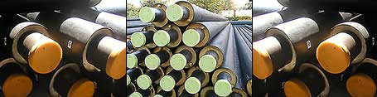

Pre-insulated pipes
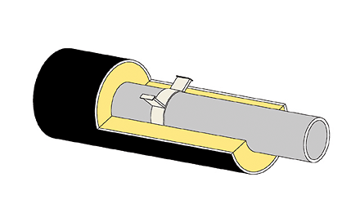

Technical data:

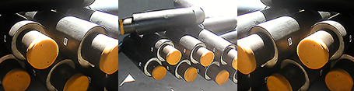

Pre-insulated elbows

Pre-insulated elbow 90°
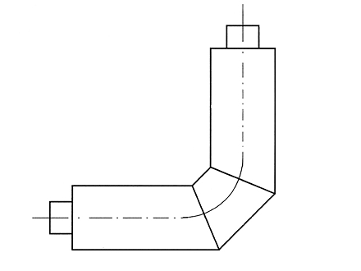

Technical data:

Pre-insulated elbow 45°
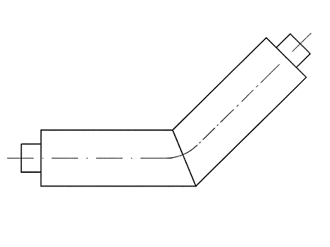

Technical data:

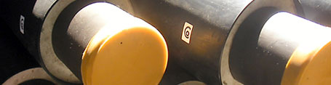

Pre-insulated t-branch

Pre-insulated straight t-branch
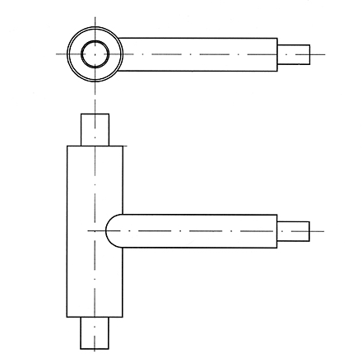

Technical data:

Pre-insulated edge t-branch
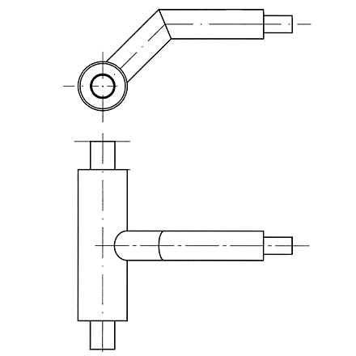

Technical data:

Pre-insulated parallel t-branch
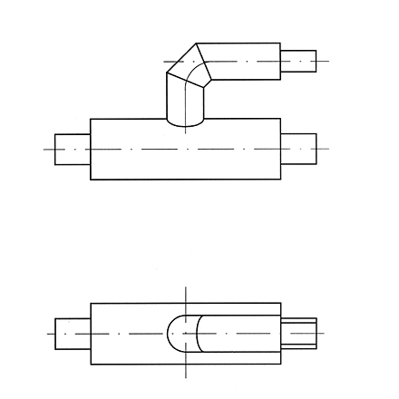

Technical data:

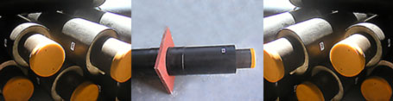

Anchor
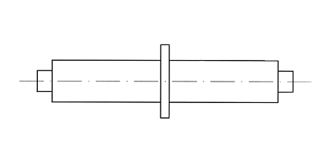

Technical data:

Pre-insulated reductions
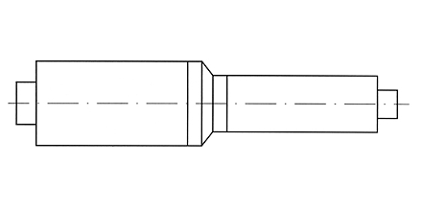

Technical data:

Compensators
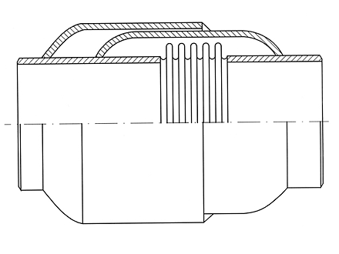

Technical data:

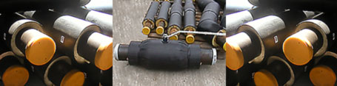

Pre-insulated valves

Pre-insulated closing valve
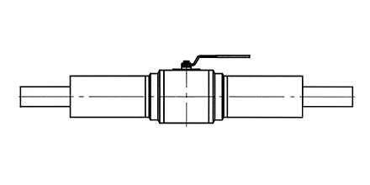

Technical data:

Pre-insulated drainage valve
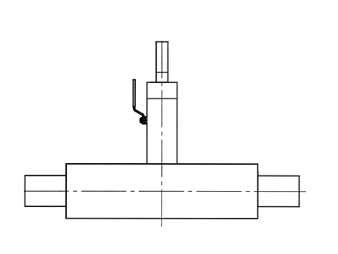

Technical data:

Thermoshrincable muffs
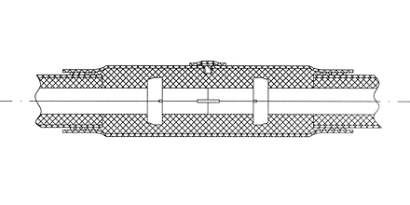

Technical data:

Accessories
AVKO jsc also supplies completing products for building of pre-insulated piping systems, including:
- end caps
- end shrinkable sleeves
- seal rings
- foam pads

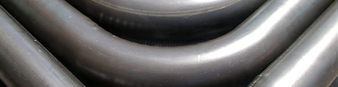
Cold bent steel elbows
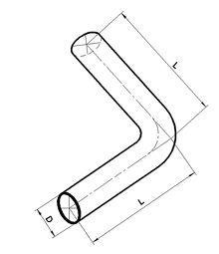 | The cold bent elbows are produced from longitudinally welded steel pipes, which conform to EN 10217-2 or DIN 1626.  The bent elbow satisfies the quality requirements, stated in EN 448:2003.  Standard sizes include DN 20 to DN 200 with angle 45° and 90° and bending radius 2,5D.  On request it is possible to be manufactured elbows with different angle and length of the legs.

Technical data

Forged steel fittings with welded legs
Forged steel elbows
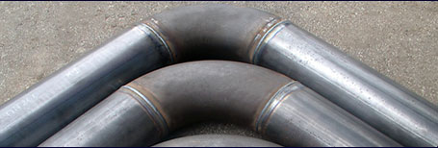
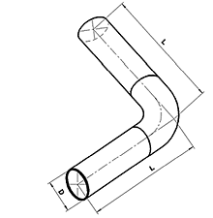 | These elbows consist of a forged fitting conforming to ASME/ANSI B 16.9 / B 16.28 or DIN 2605-1991 with bending radius 1,5D to which there are welded longitudinally welded steel pipes conforming to EN 10217 or DIN 1626.  The quality of the welding seams conforms to BSS EN 25817-B.  Standard offered sizes include DN 20 to DN 400 with angle 45° and 90°.  On request it is possible to be manufactured elbows with different sizes.

Technical data

Forged steel reductions
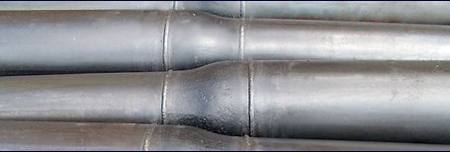
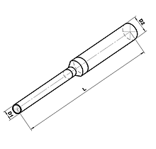 | These reductions consist of a forged fitting conforming to ASME/ANSI B 16.9 or DIN to which there are welded longitudinally welded steel pipes conforming to EN 10217 or DIN 1626.  The quality of the welding seams conforms to BSS EN 25817-B.  Standard offered sizes include DN 25/20 to DN 250/200.  On request it is possible to be manufactured reductions with different sizes .

Technical data

Forged steel tee-pieces
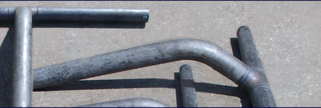
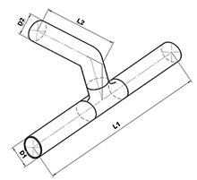 | Forged tee-pieces are manufactured in three types – straight, angular and parallel. Each type can be produced by using either forged tee piece with equal sizes in all ends, or reduction tee piece.  The quality of the welding seams conforms to BSS EN 25817-B.  Standard offered sizes include DN 20 to DN 400.  On request it is possible to be manufactured tee-pieces with different sizes.

Technical data

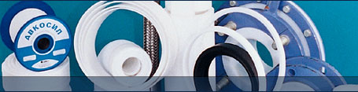
Properties of polytetrafluorethylene (PTFE) made products
The chemical structure of PTFE is a long carbon chain surrounded by fluoride atoms in a kind of protective casing. This chemical structure predetermines the exceptional properties and numerous applications of PTFE, making it completely different from the rest of polymers.

PTFE products guarantee:
- Reliable service at temperatures above the temperature range of all thermoplastic materials. In various working media, service temperature can reach up to 260 °Ѡfor continuous service. PTFE remains stable even when exposed to temperatures of -200 °ѻ
- Excellent anti-aging property even at higher temperatures and in the presence of solvents, oils, oxidizers, UV radiation, or other kind of working environment's impact;
- PTFE is biologically resistant to ferments and microbes. It is chemically pure and inert, therefore does not affect the working environment;
- Extremely non-adhesive as a solid material, PTFE has very low surface tension - viscose, volatile or squashy liquids do not stick to the contacting surfaces. Allows excellent washing and sterilizing;
- Impervious to the most corrosive organic and inorganic chemical compounds;
- High electrical resistance;
- Nonflammable;
- Low thermal conductivity;
- Lowest coeficient of friction compared to any other similar material;
- Wear property can be made appropriate for any working environment by adding high-purity fillers, such as graphite, molybdenum disulfide, glass, or bronze.

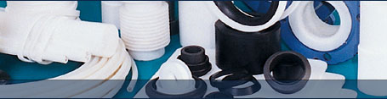

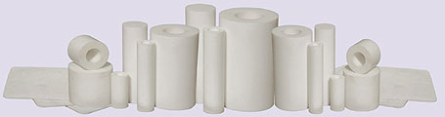
SEMI-FINISHED PRODUCTS AVKOFLON®
:: MATERIALS

- pure PTFE;
- PTFE with glass filler;
- PTFE with graphite filler;
- PTFE with coal filler;
- PTFE with molybdenum disulfide filler;
- PTFE with bronze filler.

:: SHEETS

Standard sizes *, mm | 300x300;500x500;600x600;1000x1000;1200x1200
Standard thicknesses *, mm | 1, 2, 3, 4, 5 . . . 100

:: PRESSED RODS

Standard sizes*, mm
32 | 38 | 45 | 55 | 60 | 70 | 80 | 90 | 100 | 110 | 120 | 135 | 145 | 160 | 175 | 195
35 | 40 | 50 | 58 | 65 | 75 | 85 | 95 | 105 | 115 | 125 | 140 | 150 | 165 | 185 | 200

Allowable size tolerance*, mm
Diameter | up to 40 | 40÷70 | 70÷80 | 80÷100 | over 100
Tolerance | +2 | +2.8 | +3.2 | +4.0 | on request

Standard heights , mm | max 230
Allowable height tolerance*, mm | ±10

:: PRESSED TUBES

Standard sizes* (D x d, mm)
32x20 | 60x25 | 70x50 | 80x40 | 90x55 | 110x75 | 145x85 | 195x170
35x25 | 60x30 | 70x55 | 80x45 | 94x45 | 115x80 | 145x100 | 225x50
38x18 | 60x35 | 75x20 | 80x50 | 94x55 | 115x90 | 145x120 | 225x190
42x18 | 60x40 | 75x25 | 80x55 | 94x60 | 120x40 | 150x100 | 235x195
45x25 | 65x20 | 75x30 | 80x60 | 94x65 | 120x65 | 150x105 | 235x205
50x20 | 65x25 | 75x35 | 85x30 | 100x30 | 120x75 | 160x125 | 305x285
50x25 | 65x30 | 75x40 | 85x40 | 100x45 | 120x100 | 160x130 | 380x340
50x30 | 65x35 | 75x45 | 85x50 | 100x55 | 120x105 | 165x140 | 430x383
50x35 | 65x45 | 75x50 | 85x55 | 100x60 | 125x80 | 174x122 | 630x577
55x25 | 65x50 | 75x55 | 85x60 | 100x70 | 135x75 | 174x140
55x30 | 70x20 | 75x60 | 85x65 | 100x75 | 135x85 | 185x155
55x35 | 70x25 | 80x20 | 90x25 | 100x80 | 135x105 | 185x160
55x40 | 70x30 | 80x25 | 90x40 | 100x85 | 140x75 | 185x165
55x45 | 70x40 | 80x30 | 90x45 | 100x90 | 140x95 | 195x155
60x20 | 70x45 | 80x35 | 90x50 | 105x65 | 140x110 | 195x165

Allowable size tolerance*, mm
Diameter | up to 50 | 50÷70 | 70÷90 | 90÷110 | 110÷150 | over 150
Tolerance  D  d | +2.0  -2.0 | +2.8  -2.8 | +3.6  -3.6 | +4.9  -4.0 | +7  -6 | +max 20  -max 20

Standard heights, mm | max 230
Allowable height tolerance*, mm | ±10

* Other sizes and tolerances - on request

READY-MADE PRODUCTS AVKOFLON
PTFE extruded rods
Standard sizes*, (D, mm) | ø6 ÷ ø205
Standard lengths, (m) | 1; 2
Tolerances*
Diameter:  <10  10 ÷ 20  20 ÷ 30  30 ÷ 50  50 ÷ 100  >100 | D  +0.4  +0.5  +1.0  +1.5  +2.0  +4.0

PTFE extruded tubes
Standard sizes*, (D, mm) | 10x5 ÷360x150
Standard lengths, (m) | 1; 2
Tolerances*
Diameter:  <10  10 ÷ 20  20 ÷ 30  30 ÷ 50  50 ÷ 100  >100 | D  +0.5/-0.5  +0.5/-0.5  +1.0/-1.0  +1.5/-1.5  +2.0/-2.0  +4.0/-3.0

Flat gaskets
Description:
Flat gaskets made of pure or filler-loaded PTFE.
Intended use:
For sealing of the flanges of pipes, valves, fittings, containers etc. made of steel, glass, plastics, or ceramics.
Envelope gaskets
Description:
Flat gaskets made of pure PTFE with insertion.
Application:
For sealing of flanges, valves, tanks, boilers, mixers, etc. products, made of steel, glass, plastics, ceramics, or graphite.
Sealing on the inside diameter
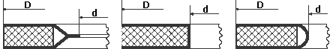
Sealing on the outside diameter
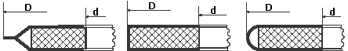

PTFE sliding bearingd
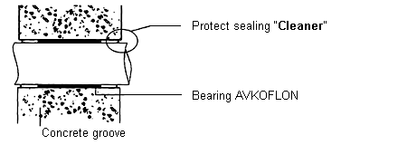
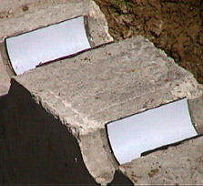 | Application:  Applied in machine joints to secure the support and relative translation of individual machine parts. Used also in bridge engineering, construction of chimneys, buildings, tunnels, pipelines, etc.
Advantages of PTFE, determining its wide application range:
- Extremely low coefficient of friction;
- Chemically inert;
- Excellent chemical resistance;
- High service temperature, stability from -200°C up to +260°C;
- Low nad steady wear factor;
- Excellent dielectric properties, thermal insulator;
- Abrasion-resistant;
- Anti-aging and non-fatigue properties;
- No need for lubrication.
Most commonly used materials:
PTFE with glass filler, PTFE with MoS₂ filler, PTFE with bronze filler, PTFE with graphite filler.
"O" - Rings
Application:
The use of "O"-rings is based on an initial small deformation at the time of fitting, which secures reliable sealing properties during contact with the sealed-in fluid.
O-rings can be placed on static machine parts, as well as on rotating, or reciprocating parts.
Advantages:
Exhibits excellent resistance to extreme high temperatures in a chemically aggressive environment.
Standard sizes *
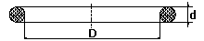

D | >12 | >20 | >25 | >30 | >80 | >200
d | 3 ±0.1 | 4 ±0.1 | 5 ±0.1 | 6 ±0.2 | 7 ±0.2 8 ±0.3 | 9 ±0.4 10 ±0.41

Standard types
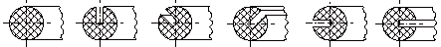

Glass-PTFE cloth
Description:
A material that combines the properties of glass cloth with the specific properties of PTFE coating and is applied in chemical and food industry, electrical engineering, packaging industry, construction, etc. Service temperature range between -200°C and +260°C.
Standard sizes:
- Rolls
Width (mm): 1000;
Thickess (mm): 0.10, 0.13, 0.15, 0.25;
Lengths (m): 30, 50, 100;
Variants: with or without self-adhesive layer;
Antistatic excution on request.
- Rolls
Width (mm): 35;
Thickess (mm): 0.13;
Lengths (m): 50;
Self-adhesive 5 mm strip along the edges.

Piston rings and stuffing-box elements made from filled PTFE
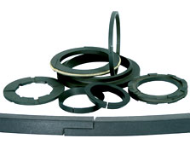 | Application:  The set of rider and sealing rings provides reliable sealing between the piston and the cylinder bush, and the set of single-, double- and triple stuffing-box elements provides the sealing of the piston rod.
Advantages:
Piston rings and stuffing-box elements made of PTFE filled with graphite, coal, coke, bronze or other fillers, display a series of specific properties:
low friction coefficient, extremely high wear resistance and extended service life, no need for lubrication, simplified junction structure, and ensured purity of technological processing wherever necessary.
Sizes:
Manufactured after customer-provided drawings, no limitations as to sizes or shape.

LINING WITH PTFE AND FLUOROPLASTICS
PTFE-lined heating bodies
Application:
For heating and temperature maintenance in aggressive fluids with ph 0-14, applied in electrodeposition, etc.

Structure:
- A metal heating pipe with protective grounding, PTFE-lined, hence, provided with the following advantages:
- extended service life and applicability for all electrolytes;
- smooth non-sticky surface determined by the anti-adhesive
properties of material;
- easy cleaning
- PTFE-made restrictors preventing the heating body from touching the tub wall.
- Marked minimal depth of dipping, preventing the heater from overloads.
- Airtight connecting box.
PTFE lined hoses
PTFE-lined corrugated and smooth-surface hoses are based on PTFE flexible tube with metal or rubber armour.
They combine a number of properties:
- Exceptional chemical resistance, resulting from the PTFE flexible tube, which is placed in direct contact with the transferred fluid, thus making the product corrosion-proof;
- Wide service temperature range from -70°C up to +230°C, depending on the working pressure;
- Excellent flexibility as a result from the appropriately corrugated PTFE flexible tube;
- High working pressure resistance, vacuum and hydraulic impact resistance coming as a result from the built-in flexible tube reinforced with steel spiral, and the outside metal stainless steel braiding or rubber flexible tube;
- The passing fluids is 100% transferred due to the anti-adhesive properties of PTFE, and excellent self-cleaning is also effected.

Tanks, pipes, fittings and fixtures with industrial PTFE and
fluoroplastic lining
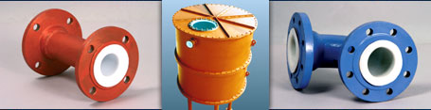
Applications:
For preserving and transporting chemically aggressive fluids, concentrated acids, bases, petrol products, etc.
PTFE is known for its universal chemical resistance, which enables its wide application in the production of storage vessels and transportation pipelines for various chemicals.
Steel or reinforced plastic tanks can be used for highly corrosive materials, when lined with thin PTFE sheets or fluoroplastics.
Lining carbon steel tanks with thin PTFE or fluoroplastic sheets is the best way to make inexpensive, highly corrosion-proof tanks.

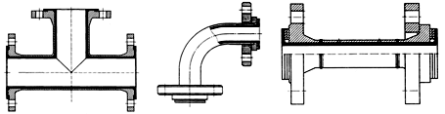
Advantages:
The application of PTFE-lined technological facilities or units in the chemical, petrochemical, pharmaceutical and food industries ensures high quality and purity of products, extended sevice life and easy maintenance of facilities.
The unique properties of fluoropolymers have made them an indispensable material for any kind of modern equipment, applied in today's broad list of industries.

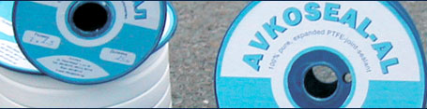
Expanded PTFE sealant for flange joints AVKOSEAL-AL
AVKOSEAL-AL is a sealant, manufactured from 100% pure expanded PTFE.
It is typically produced as a tape and is less widely used in the form of a cord, plates etc.
The expanded PTFE comprises all the exceptional operation parameters of PTFE plus the additional features acquired in the process of expansion.
To facilitate the fitting AVKOSEAL-AL is provided with a one-sided adhesive backing strip with protective layer made from special paper, which is removed before fitting.
Due to its excellent flexibility and ductility AVKOSEAL follows very easily the shape of the sealed surface, and the adhesive strip enables the quickness of the fitting.
Apart from the flange sealing AVKOSEAL-AL may be successfully used in every other case of static sealing, provided that the working parameters fall into the range PTFE's values.
Sizes and lengths in one reel:
Standard size | Standard size | Length in  roll |  | Standard size | Standard size | Length in  roll
mm | Ø mm | m |  | mm | Ø mm | m
 | 1 | 50 | 100 | 14 x 5.0 | 14 | 6 | 20
3 x 1.5 | 3 | 30 | 60 | 17 x 6.0 | 17 | 5 | 20
5 x 2.0 | 5 | 25 | 50 | 20 x 7.0 | - | 5 | 20
7 x 2.5 | 7 | 20 | 40 | 22 x 5.0 | - | 5 | 20
10 x 3.0 | 10 | 10 | 40 | 25 x 5.0 | - | 5 | 20
12 x 4.0 | 12 | 7.5 | 25 | 28 x 5.0 | - | 5 | 20

Advantages of the material
- Chemical resistance to almost all aggressive mediums
(РН range 0 - 14);
- Temperature range: from - 240 °С to +290 ^{о}С,
short periods up to 310 ^{о}C;
- Physiologically safe - without taste and smell, nontoxic, does not contain soluble components, not influenced by microorganisms (moulds);
- Ensures cleanness of the medium;
- Hydrophobic, non ageing, resistant to UV - unlimited operational validity;
- In working conditions AVKOSEAL-AL does not change its hardness and brittleness;
- Nonflammable and noncombustible;
- Short fitting time, since AVKOSEAL-AL is ready for application and is not made from sheet material;
- Quick disassembly: AVKOSEAL-AL may be easily removed, without traces;
- No need of cutting (moulding) of the sealing;
- Complete use: no waste material;
- No need of additional mechanical treatment of the surfaces sealed: AVKOSEAL-AL is easily adapted and compensates deviations from shape and condition of the surface;
- The flexibility of AVKOSEAL-AL allows sealing of the most complicated configurations;
- Small storage costs - the material is packed in reels, as only several of them are sufficient for any sealing applications.

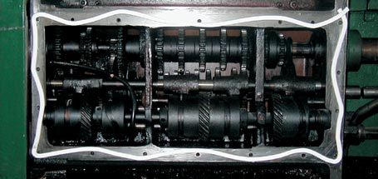

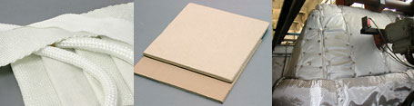

Thermo-insulating materials
Heat isolation of machines, devices and energy transporting installations in the industry is of crucial importance for increasing of the energy effectiveness, achieving longer exploitation terms of the industrial equipment and preserving the operational personnel from health hazards.
The thermo isolating materials of AVKO jsc are based upon silicate fibers and for more than a decade now work successfully as a substitute for the asbestos products when working under extreme high temperatures (1000 ÷ 1200 °C).
The great diversity of thermo isolating products offered by AVKO jsc makes possible the solving the of any isolation problem.
To guarantee the quality of its products AVKO jsc may present The Golden Medal received at the International Technical Fair in Plovdiv in1997 for a series of silicate products.

Textile thermo-insulating materials

AVKOTHERM® 52, AVKOTHERM® 62 - Thermo-insulating clothes
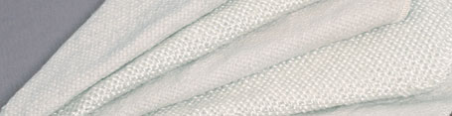
Thermo-insulating cloths produced on the basis of ceramic fibres are designed primarily for heat insulation, protection in case of fire related jobs (such as welding, gas cutting), production of thermal protection screens, devices and clothing. The cloths have the following advantages: regular structure, resistant to burning out, same strength in weft and warp.
AVKOTHERM® | 52 | 62 C | 62 C/AR | 62 T | 62 T/AR
Description | Glass cloth | Ceramic cloth medium type | Ceramic cloth medium type, reinforced with metal wire | Ceramic cloth heavy type | Ceramic cloth heavy type reinforced with metal wire
Standard width | 1000 ± 20 mm | 1000 ± 20 mm  1200 ± 20 mm | 1000 ± 20 mm  1200 ± 20 mm | 1000 ± 20 mm  1200 ± 20 mm | 1000 ± 20 mm  1200 ± 20 mm
Surface density | 1000 ± 50 g/m² | 1000 ± 50 g/m² | 1100 ± 50 g/m² | 1400 ± 50 g/m² | 1460 ± 50 g/m²
Thermal resistance | 450 °C | 980 °C | 1200 °C | 980 °C | 1200 °C

AVKOTHERM® 54, AVKOTHERM® 64 - Thermo-insulating tapes
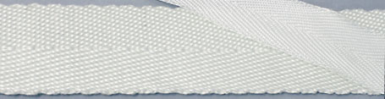
The thermo-insulating tapes AVKOTHERM® 54 (series glass tapes) and AVKOTHERM® 64 (series ceramic tapes) find application as universal insulations in a wide range of industrial fields. Used basicaly for: insulation of cables and pipelines; insulation of gates of fireplaces, boilers and furnaces and in special manufacturing processes, for example outer coating of transport bands in glass industry and elsewhere.
Thermo-insulating tapes are made in standard widths from 20 to 320 mm.

AVKOTHERM® 63 - Fire-extinguishing blankkets
The fire-extinguishing blankets AVKOTHERM® 63 are designed on the dasis of siliceous heat insulating cloths and serve for protection from fire in places, where it is not recommended to apply water, foam, etc. Those find application for covering parts of industrial systems or electrical cable, if located nearby fire hazard high temperatures; as well as for fire extinguishing in premises containing easy flammable and explosive substances - studios, laboratories; for protection of people against fire and others.
Sizes | 1200 x 1800 mm
Mass | 2.3 kg
Humidity | 1.3 %
Flexibility | without residual deformation
Dielectric strength | > 1 MW
Number of fibers per 10 cm
- on warp | 72 ± 2
- on weft | 28 ± 2
Fire extinguishing effect for sunflower oil | extinguishes
Resistance to moths and microorganisms | resistant

Thermo-insulating cords
The thermo-insulating cords manufactured from siliceous fibers are mainly used for heat insulating of pipelines carrying steam, heaters, industrial equipment, etc. working at high temperature. It is suitable for static sealing of lids, hatches, doors, etc. and also sealing of furnaces, boilers, ventilators, etc.
AVKOPACK® 501  Technical data in PDF format | 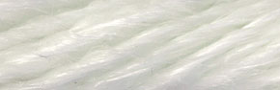
Composition | Тwisted cord made from textured glass yarn
Working temperature | 450 °C
Density | 0.6 ± 10 %

AVKOPACK® 501H  Technical data in PDF format | 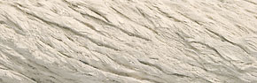
Composition | Cord made of glass fibers, reinforced with outside hose made of glass and cotton yarn with surface processed with special system of silicate materials
Working temperature | 700 °C
Density | 0.6 ± 10 %

AVKOPACK® 503 EKO  Technical data in PDF format | 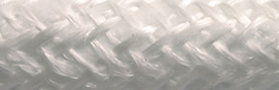
Composition | Ecorope, braided from ceramic fibers with inner core from ecoproduct from ceramic with content of Al₂O₃ < 1%
Working temperature | 1100 °C
Density | Ø35 - 0.3 ±10 % ; Ø80 - 0.16 ±10 %

AVKOPACK® 505  Technical data in PDF format | 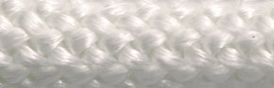
Composition | Elastic cord braided of textured glass yarn
Working temperature | 500 °C
Density | 0.6 ± 10 %

AVKOPACK® 600/600AR  Technical data in PDF format | 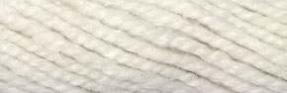
Composition | Twisted cord made from ceramic yarn and basic fibres made of glass or steel. The cord is produced with filling of ceramic yarn or silicate material
Working temperature | 980 / 1200 °C
Density | 0.5 ± 10 %

AVKOPACK® 601  Technical data in PDF format | 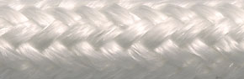
Composition | Cord made of silicate filling and dense glass braiding
Working temperature | 1000 °C
Density | 0.5 ± 10 %

AVKOPACK® 603  Technical data in PDF format | 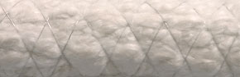
Composition | Cord made of parallel ceramic fibres firmly braided with inconel fibre
Working temperature | 1200 °C
Density | 0.55 ± 10 %

AVKOPACK® 506, AVKOPACK® 606 - Glass and ceramic hollow sealing sleeves
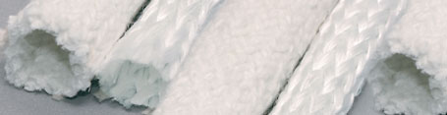
Advanced sealing product braided from:
- textured or filament glass yarn;
- ceramic yarn with glass or metal bearing wire;
Working temperature
glass sleeve | 550 °C
ceramic sleeve with glass fiber | 980 °C
ceramic sleeve with metal fiber | 1200 °C
Standard sizes
glass sleeves | Ø10, Ø12, Ø14, Ø15, Ø20, Ø25, Ø30, Ø35, Ø40
ceramic sleeves | Ø20, Ø25, Ø30, Ø35, Ø40
Wall thickness
glass sleeves | 1 ÷ 3
ceramic sleeves | 2 ÷ 4

Thermal insulation mattresses for multiple use

AVKOTHERM® 57 - Thermal insulation mattresses for multiple use
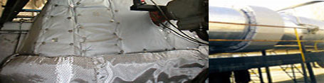

Description
АВКОТЕРМ® 57 is a multi-layered insulation with thermal- resistant textile casing attached by arresting springs. Over the outer surface of the clothing are situated fastening together elements that prove the stability of fixing the clothing to the insulating object.
The elaboration differs with its specific method of approach to every different type of the insulation object, referring its adaptability to work at different exploitation conditions and working media temperatures from -25 to 1100°С, high content of humidity, acids or other aggressive fluids, as well as characteristics of the atmospheric conditions.

Applications
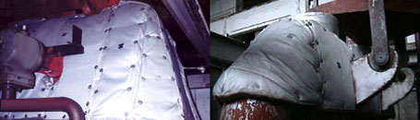
Applications:
- Fixture
- Flanges
- Tanks
- Steam generators
- Heat exchangers
- Vessels under pressure
- Flexible joints
- Valves
- Pumps
- Turbines
- Ventilators
- Non-standard equipment
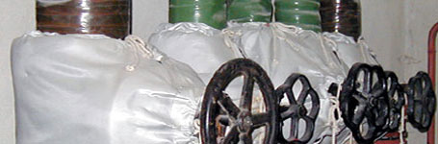

Advantages
- Energy saving - considerable level of decreasing the heating losses;
- Possibility to be used in a wide temperature range from -25 to 1100 °С;
- The construction could be tight for liquids and not to attain them in its volume;
- Resistance to abrasives
- Allows a repeated mounting and dismantling, without changing the parameters characterizing the quality of the product;
- Quick and easy mounting and dismantling, without using instruments;
- Comparatively lower weight from the other insulating constructions;
- Vibration-resistance - reliable fixing and flexibility to АВКОТЕРМ® 57 provides invariability of the disposition;
- Noise insulation;
- Fire protection - the materials used in the constructions working above 200°C - 250 °C are incombustible. Following a request a construction with combustible materials could be elaborated and at lowered temperatures, too;
- Protection of the staff servicing from incineration. The temperature of the surface is not exceeding 45 °C, at 25 °C of the environment;
- After a request specific conditions of exploitation are reported, which guarantees free of all average work and long life of the product.

Thermo-insulating boards

AVKOTHERM® 65 and AVKOTHERM® 65/1
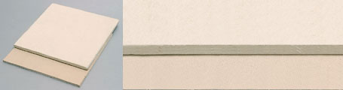
The thermo-insulating boards AVKOTHERM® 65 and AVKOTHERM® 65/1 are complete non-asbestos material. They are made of inorganic mineral fibres with a limited quantity of fillings. They are especially appropriate for sealing manufacture of various sizes, used for heat insulation under high temperatures.
 | AVKOTHERM® 65 | AVKOTHERM® 65/1
Standard sizes | 1000 x 1000 mm | 1000 x 1000 mm
Standard thickness | 1.5 - 10 mm | 1.5 - 10 mm
Working temperature | 850 °C | 1200 °C
Tensile strength (DIN 52910) | 3.00 N/mm² | 3.30 N/mm²
Specific weight (DIN 3752) | 1.00 g/cm³ | 0.90 g/cm³
Thermal conductivity (at 400°C) | 0.100 W/mK | 0.100 W/mK

Thermoinsulation materials made of basaltic mineral wool

AVKOTHERM® 65 and AVKOTHERM® 65/1
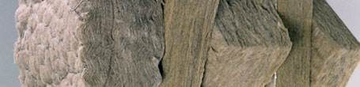

General properties
- Inorganic product, obtained from basaltic mineral fibers;
- Non combustible and not inflammable;
- Fonoisolating;
- Chemical inert, does not attack other materials, is not corroded by other materials;
- Is not toxic, does not pollute the environment;
- Does not age, does not rot;
- Thermo isolating up to 700 °C;
- Does not change its shape and dimensions;
- Easy to handle and work with it;
- The product is waterproof;

Field of application
- Thermal and fono-isolation, protection against fire, when used in construction with horizontal or vertical surfaces;
- Thermal isolation of district heating pipes in civilian and industrial installations;
- The production of isolating panel, suspended roof, partition panel;
- Thermal isolation of channel from refrigerating chambers;
- Thermal isolation for industrial installation, ships, train wagon, frigorific cars and chambers;
- Thermal and fono isolation of prefab houses, partition walls, curtain walls, facade;
- Thermal and fono isolation of passable terrace, (with suitable precautions), and roofs.

Technical Specification
Download the technical data in PDF
AVKO JSC preserves the right to make any changes to the product and respectively its technical characteristics at any time.

Tehermo-insulating cladding AVKOTHERM® 66/11
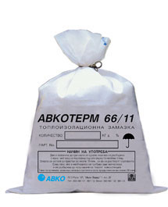
AVKOTHERM® 66/11 is specially developed mixture of inorganic mineral fibers, cement and chemically inert fillers.
After stirring with water, this composition forms a defensive cladding with common usage and self-drying effect. It is used for spreading on a ready thermoinsulation with a steel wire web fixed on it. The cladding prevents the already put thermoinsulation from atmospheric and mechanic influence.
Pain, ferolites and other organic claddings may be spread on it.
Dansity | 1300 kg/m³
Working temperature | 120 - 700 °C
Compression strength | 20 - 25 MPa
Tensile strength | 6 - 7 MPa
Thermal conductivity coefficient (at 25 °C) | 0.28

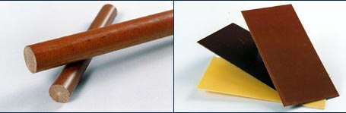
ELECTROINSULATING MATERIALS
AVKOLIT 551 (PHENOLIC GLASS CLOTH LAMINATED SHEETS)
The phenolic glass cloth laminated sheets are laminated material, made through the hot pressing of two or more layers of alkali-free glass material (with unbroken fibre), reinforced with thermoreactive resin of phenol or epoxide type.
* Delivery at request of copper-folio-faced phenolic glass cloth laminated sheets.

AVKOLIT 451 (PHENOLIC COTTON CLOTH LAMINATED SHEETS)
The phenolic cotton cloth laminated sheets are made by a laminated material through the hot pressing of two or more layers of cotton fabric, reinforced with synthetic thermoreactive resins of phenol-formaldehyde type, cresol-formaldehydes, mixture of these resins or their modifications.

AVKOLIT 452 (PHENOLIC COTTON CLOTH LAMINATED ROD)
The phenolic cotton cloth laminated rods with circular section are made through pressing of cotton fibre in a pressform, reinforced with thermoreactive resin of phenol type.

AVKOLIT 851 (PHENOLIC PAPER LAMINATED SHEETS)
The phenolic paper laminated sheets is a layered material, made through the hotpressing of two or more layers of electroinsulating paper, reinforced with synthetic thermoreactive resins of phenol-formaldehyde and cresol-formaldehyde type, mixture of these resins or their modifications.

The surface area of all materials is plain, smooth, evenly painted in natural color, without air or gas bubbles and current-carring switches. They can be mechanically treated: cut, drilled, turned on a lathe, milled, punched with no occurrence of cracks or dislodges.

TECHNICAL PARAMETERS
 | AVKOLIT  551 | AVKOLIT  451 | AVKOLIT  452 | AVKOLIT  851
Size | 1980 x 980  ?10 mm | 1980 x 980  ?10 mm | 1000  ? 5 mm | 1980 x 980 ?10 mm
Thicknesses (diameters) | 0.4 ÷ 50 mm | 0.8 ÷ 50 mm | Ø6 ÷ Ø200 | 0.4 ÷ 50 mm
Density | 1.7 ÷ 1.9 g/cm³ | 1.3 ÷ 1.4 g/cm³ | 1.32 ÷ 1.39 g/cm³ | 1.3 ÷ 1.4 g/cm³
Flexural strength perpendicular to lamination | > 340 MPa | > 70 MPa | > 88 MPa | > 90 MPa
Bonding strength |  | > 5500 N |  | > 2800 N
Notch impact strength parallel to lamination (Charpy) | > 33 kJ/m²
Dielectric strength perpendicular to lamination  (in oil 90 ? 2 ? C ) | > 14,2 MV/m | > 2 MV/m  (1.5-2 mm) |  | > 12 MV/m
Breakdown voltage parallel to lamination (in oil 90 ? 2 ? C ) | > 35 kV
Breakdown voltage parallel to lamination  (in transformer oil 20 ? 5 ? C ) |  |  | > 10 kV | > 10 kV
Insulation resistance after impregnated in water | > 5x10⁸Om
Insulation resistance parallel to the lamination |  |  | > 1x10⁸Om | > 1x10⁹Om

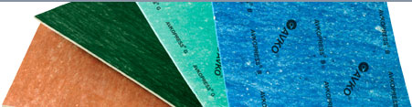
COMPRESSED JOINTING SHEETS
:: NA 202 (red colour)

Oil-resistant rubber composed by organic fibres, NBR, for light to medium load pressure. Very suitable for use in the automotive and food industry.

:: NA Extra (dark green colour)

Jointing sheet composed by synthetic fibres with rubber, suitable for use in air, water and unagressive areas.

:: AVKOPRESS G (green colour)

Jointing sheet composed by high quality synthetic fibres and rubber systems. Suitable for use in air, water and unagressive areas. It is applicable in flange sealing, front surfaces etc.

:: AVKOPRESS B (blue colour)

Jointing sheet composed by high quality synthetic fibres and rubber systems. Suitable for use in air, water and unagressive areas. It is applicable in flange sealing, front surfaces etc..

Technical parameters
Type | NA 202 | NA Extra | AVKOPRESS G | AVKOPRESS B
Size, mm | 1500x1500 | 1500x1500 | 1500x2000 | 1500x2000
Thickness, mm | 0.5; 0.8; 1.0; 2.0; 3.0 | 0.5; 0.8; 1.0; 2.0; 3.0 | 0.5; 1.0; 1.5; 2.0; 2.5; 3.0; 4.0; 5.0 | 0.5; 1.0; 1.5; 2.0; 2.5; 3.0; 4.0; 5.0
Max. temperature*,°C | 180 | 290 | 300 | 360
Max. temperature  with steam*,°C | 120 | 260 | 250 | 300
Max. pressure*, bar | 40 | 100 | 45 | 60
Specific weight ,g/cm³ | 1.8 +1% | 1.75 +1% | 1.9 +1% | 1.9 +1%
Shrinkage,% | 8 | 7 | 11 | 12
Recovery,% | 50 | 55 | 52 | 58
Tensile strength, MPa | 7 | 7 | 8 | 10

* The values of the temperature and the pressure are maximal. The using of the material at maximal values of the indices together is not recommended. These values are approximate and depend not only on the type of the sealing material but on additional factors, like the conditions of mounting. Very important parameters are the thickness of the sheet, the type of the fluid, the type of the flange and the surface tensions. Their use in vapor requires special technical attention.

Compressed Jointing Sheets are attended by "Gasket installation procedures" recommended from ESA (European Sealing Association).
Download: Gasket installation procedures

:: FINISHED FLAT GASKETS

The finished flat gaskets are produced from non-asbestos jointing sheets, described in this brochure. The goods are available in wide range of dimensions covered, according to DIN 2690, DIN 2691, DIN 2692, specially for shipbuilding industry 3Н-632-92 and non-standart sizes on request.
Features:
- lack of processing wastes;
- economy of money and time;
- high quality.

:: DEVICE FOR CUTTING OF FINISHED GASKETS

The device intended for cutting of gaskets from sheet packed material.
It allows a maximum usage of the material and meanwhile is very suitable and easy running.
Maximum diameter when making a gasket with fixing of the semifinal product in the center of the work board - ø500 мм.
Maximum diameter, when making a gasket with fixing of the semifinal product in the corner of the work board - ø1000 мм.

TECHNICAL RUBBER SHEET
Technical parameters
 |  | rubber ordinery sheet | rubber oil resistance sheet | rubber acid resistance sheet | rubber thermal resistance sheet
Width | mm | 1000 | 1000 | 1000 | 1000
Thicknesses | mm | 1 ÷ 20 | 1 ÷ 20 | 1 ÷ 20 | 1 ÷ 20
Density | g/cm³ | 1.5 ÷ 2% | 1.5 ÷ 2% | 1.5 ÷ 2% | 1.5 ÷ 2%
Tensile strength | MPa | 4.1 | 5.6 | 4.8 | 6.1
Broken extension rate | % | 280 | 260 | 260 | 300
Hardness |  | 75 | 72 | 68 | 73
Weight increasing after dipping in petrol+benzene (75:25) | % |  | 16.5
Weight increasing after dipping into industrial oil for transformer | % |  | 6.8
Ageing rate  20% H2SO4, 23 °C + 24 h  20% NaOH, 23 °C + 24 h | % |  |  | 0.8  0.8
Recommended work temperature | °C |  |  |  | 80 - 100
Instant temperature | °C |  |  |  | 200

 | FRICTION MATERIALS
 | Non-asbestos brake textile | 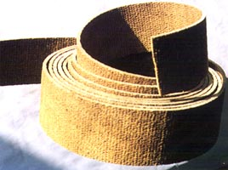
Composition | A synthetic textile, made of kevlar and glass fibers, reinforced with copper fiber and steeped in impregnation mixture.
Application | In braking gears of ropeways, traction engines, excavators, cranes and other hoists.
Technical characteristics
  Working temperature | -300°C
  Water absorption for 24 hours | max. 18%
  Friction coefficient | min 0,20
  Linear wear | max. 0.22 mm/2h
  Dimensions | width  from 40 till 260 mm  thickness  from 4 till 25 mm
  Roll length | from 10 till 15 m

Automobile plates
Cone rings for motor-cultivators

 | 
 | PREVECTRON® 2 - E. S. E. Lightning Conductors
  AVKO JSC offers lighting-protectors PREVECTRON® 2, produced by INDELEC® - France and we are the one and only representative for Bulgaria of this product.
 | 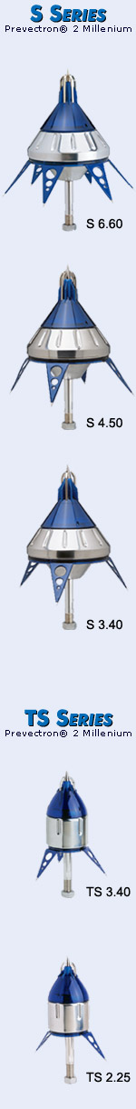 |  | Key benefits  The skills of INDELEC’s engineers, the variety of tests carried out in both high-voltage laboratories and real-life lightning conditions, and the experience gained from the thousands of PREVECTRON®2 installations around the world, have allowed us to develop a complete range of lightning conductors offering a host of key benefits:
- 6-model range offering customized solutions for each project (easthetic constraints, required protection area, etc.)
- fully autonomous operation
- total reliability, even in extreme climatic conditions
- proven, robust design able to withstand multiple lightning strikes
- lightning conductor only becomes active when electrical field intensity rises (lightning discharge likely), the PREVECTRON®2 presents no danger to the site
- straightforward installation & maintenance using tools specially developed by INDELEC, including protection calculation software, strike counter and PREVECTRON® tester
- high-voltage laboratory test results available on request
- real-life test results & scientific reports available on request
- ultra-safe capture tip thanks to full electrical continuity between the tip and the earth point
- ISO 9001-2000 manufacturing process (certificate No.116884)
Protection area
The protection area Rp of a PREVECTRON®2 lightning conductor is calculated according to French Standard NF C 17-102, thus
The protection area depends on a number of factors:
- Gain in triggering time T(µs) of the chosen PREVECTRON®2
- L(m) = V(m/µs); V* = 1 m/µs
T* | S 6.60 | S 4.50 | S 3.40 | TS 3.40 | TS 2.25
 | 60 | 50 | 40 | 40 | 25
- * values obtained through tests conducted in high voltage laboratories.
- D(m) = 20, 45, or 60, depending on the protection level required (I, II, or III) on a given site, according to the lightning risk assessment guide.
- the actual height of the lightning air terminal above the surface to be protected:
h (where h < 5 m, for Rp see table below).
 |  |  | Protection Radii
Level I : D=20m
high protection
h(m) | 2 | 3 | 4 | 5 | 10
S 6.60 | 31 | 47 | 63 | 79 | 79
S 4.50 | 27 | 41 | 55 | 68 | 69
S 3.40 | 23 | 35 | 46 | 58 | 59
TS 3.40 | 23 | 35 | 46 | 58 | 59
TS 2.25 | 17 | 25 | 34 | 42 | 44
TS 2.10 | 10 | 15 | 21 | 26 | 26

Level II : D=45m
medium protection
h(m) | 2 | 3 | 4 | 5 | 10
S 6.60 | 39 | 58 | 78 | 97 | 99
S 4.50 | 34 | 52 | 69 | 86 | 88
S 3.40 | 30 | 45 | 60 | 75 | 77
TS 3.40 | 30 | 45 | 60 | 75 | 77
TS 2.25 | 23 | 34 | 46 | 57 | 61
TS 2.10 | 15 | 22 | 30 | 38 | 38

Level III : D=60m
standard protection
h(m) | 2 | 3 | 4 | 5 | 10
S 6.60 | 43 | 64 | 85 | 107 | 109
S 4.50 | 38 | 57 | 76 | 95 | 98
S 3.40 | 33 | 50 | 67 | 84 | 87
TS 3.40 | 33 | 50 | 67 | 84 | 87
TS 2.25 | 26 | 39 | 52 | 65 | 69
TS 2.10 | 17 | 26 | 34 | 43 | 44

WOODWORKING MACHINES
:: Woodworking copying lathes R-110 и R-154
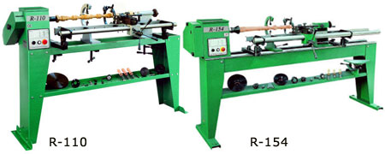
Technical specifications |  | R - 110 | R - 154
Distance between centres | mm | 1100 | 1500
Centres height | mm | 230 | 230
Front spindle end
-outer thread |  | M33 DIN 800 | M60 DIN 800
-cylindrical hole |  | ø20 H7/M12 | ø36 H7/34
Spindle rotation speed | min⁻¹ | 720, 1150,  1750, 2800 | 650, 1000,  1800, 3000
Tailstock |  | MK2 | MK2
Copying length | mm | 1000 | 1350
Copying diameter | mm | ø100 | ø100
Motor power | kW | 0.75 | 1.5
Overall dimensions
length | mm | 1700 | 2350
width | mm | 500 | 550
height | mm | 1140 | 1165
weight | kg | 120 | 400

 | WOODWORKING MACHINES
 | :: Universal band saw machines BU 634, BU 804
 | 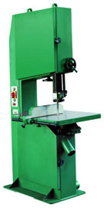
  Technical specifications |  | BU 634 | BU 804
  Drive wheel diameter | mm | 630 | 800
  Max. cutting height | mm | 380 | 450
  Distance between the saw blade and the body | mm | 610 | 780
  Max. saw blade length | mm | 4700 | 5750
  Max. saw blade width | mm | 32 | 40
  Max. saw blade thickness | mm | 0.6 | 0.8
  Blade speed | m/s | 28 | 28
  Table dimensions | mm | 630 - 710 | 850 - 900
  Table tilting | ° | 0 - 45 | 0 - 45
  Motor power | kW | 4 | 4
  Overall dimensions
  length | mm | 1200 | 1150
  width | mm | 1000 | 1100
  height | mm | 2160 | 2500
  weight | kg | 650 | 750

WOODWORKING MACHINES
:: Band saw welding machine AZL 403
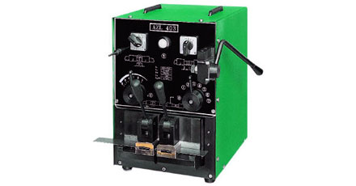
Technical specifications
Range of welded bandsaws for wood cutting
width | mm | 10 ÷ 50
thickness | mm | 0.4 ÷ 0.9
Range of welded bandsaws for metal cutting
width | mm | 10 ÷ 25
thickness | mm | 0.5 ÷ 0.9
Range of welded bimetallic bandsaws
width | mm | 10 ÷ 25
thickness | mm | 0.5 ÷ 0.9
Power consumption | kW | 4.5
Protection rating |  | IP 22
Overall dimensions
length | mm | 500
width | mm | 340
height | mm | 430
weight | kg | 52

WOODWORKING MACHINES
:: Grinding machine for circular end band saw MZ 101
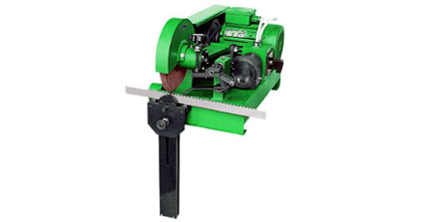
Technical specifications
Abrasive disk diameter | mm | ø 200
Disk speed | min⁻¹ | 3000
Abrasive disk tilting | ° | -5 to +15
Grinded teeth per minute |  | 72
Diameter of the grinded saw blade | mm | ø 100 ÷ ø 400
Band saw width | mm | 16 ÷ 80
Tooth pitch | mm | 5 ÷ 25
Tooth depth | mm | 2.5 ÷ 12.5
Motor power | kW | 0.55
Overall dimensions
length | mm | 600
width | mm | 300
height | mm | 300
weight | kg | 59

 | WOODWORKING MACHINES
 | :: Saw Sawage ACHL 401
 | 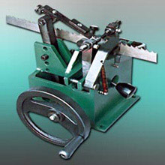
  Technical specifications
  Band saw width | mm | 6 ÷ 50
  Band saw thickness | mm | 0.4 ÷ 0.9
  Tooth pitch | mm | 3 ÷ 20
  Clasping schemes
  1) left-right-left-right
  2) left-right-straight
  Overall dimensions
  length | mm | 250
  width | mm | 210
  height | mm | 250
  weight | kg | 16

WOODWORKING MACHINES
:: Belt sanding machine MSL 244
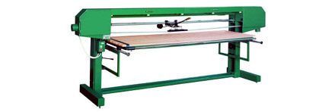
Technical specifications
Table length | mm | 2400
Table width | mm | 800
Max. belt length | mm | 7100
Min. belt width | mm | 6900
Belt width | mm | 120
Pulley diameter | mm | 300
Belt speed | m/s | 22
Motor power | kW | 4
Overall dimensions
length | mm | 3600
width | mm | 1300
height | mm | 1345
weight | kg | 320

:: Belt sanding machine MSL 083
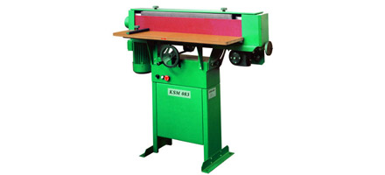
Technical specifications |  | MSL 083
Table length | mm | 800
Table width | mm | 225
Belt length | mm | 2250
Belt width | mm | 120
Pulley diameter | mm | 128
Belt speed | m/s | 11
Table tilting | ° | 0 - 45
Belt oscillation | mm | 36
Motor power | kw | 1.5
Overall dimensions
length | mm | 1200
width | mm | 450
height | mm | 1100
weight | kg | 100

WOODWORKING MACHINES
:: Circular saw blade machine CDR 700
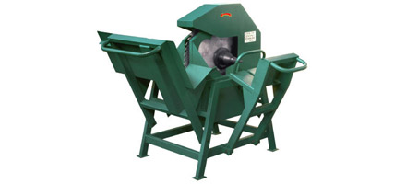
Technical specifications
Saw blade diameter | mm | ø 700
Wood cutting diameter | mm | max. 200
Motor speed | min⁻¹ | 1450
Motor power | kW | 4
Overall dimensions
length | mm | 1000
width | mm | 1000
height | mm | 1000
weight | kg | 95

WOODWORKING MACHINES
:: Circular saw blade cutter CMN 301
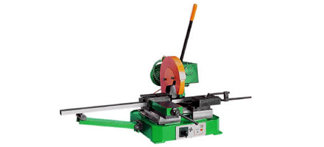
Technical specifications
Circular saw blade diameter | mm | ø 300
Clamp capacity | mm | 160
Circular saw blade inclination | ° | - 45 to +45
Circular saw blade speed | min⁻¹ | 50 / 100
Cutting possibilities: | at 45 °
 | 90
 | 50
 | 80 x 80
 | 70 x 110
Motor power | kW | 1.5/2.2
Overall dimensions
length | mm | 1500
width | mm | 1150
height | mm | 1000
weight | kg | 180

